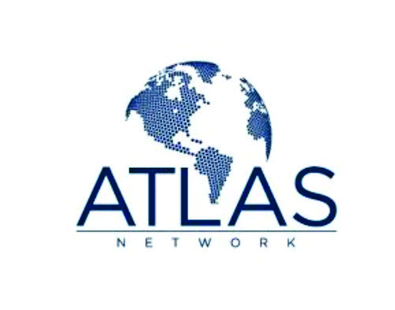

Conference on Cost of borders in Black Sea region
30-31 May 2013

Draft Agenda

Organizers: Public Association for Assistance to Free Economy and Friedrich Naumann Foundation

Partners: Georgian Foundation for Strategic and International Studies; Ukraine Institute for Economic Research and Policy Consulting
Working lunguages: English and Azerbaijani

30 May 2013, Hilton hotel

9:30 | Registration, coffee-tea
10:00-10.30 | Opening session  Roland Kobia, Head EU Delegation in Azerbaijan (to be confirmed)  Mehriban Rahimli, Coordinator of German Marshall Foundation Black Sea Trust Program in Azerbaijan  YaseminPamuk, Director of Friedrich Naumann Foundation South Caucasus Program  Zohrab Ismayilov, Head of Public Association for Assistance to Free Economy
10:30-11.30 | Panel I. European integration policy and Economic cooperation perspectives in Black Sea region  Moderator: Mehriban Rahimli  Panelists:  Dr. Rasim Musabayov, Member of Parliament (to be confirmed)  Ivlian Haindrava, Director of the South Caucasus Studies Program at the Tbilisi-based Republican Institute;  Dr. Leyla Aliyeva, President of National and International Study Center.
11:30 – 11:45 | Quick coffee/chat/cookie
11:45 – 13:00 | Panel II. Free trade, investment and mobility of people in Black Sea Region  Moderator: Yasemin Pamuk, Friedrich Naumann Foundation  Panelists:  Kanan Aslanli, Public Association for Assistance to Free Economy  Kakha Gogolashvili, Director of EU Studies at Georgian Foundation for Strategic and International Studies (GFSIS)  Dr. Svitlana Galko, Ukraine Institute for Economic Research and Policy Consulting
13:00 – 14:00 | Lunch
14:00 – 15:15 | Panel III. Effects of reforms and economic performances of Azerbaijan, Georgia and Ukraine (Doing Business, Economic Freedom Indexes, World Competiveness Index, Bertelsmann Transformation Index and etc)  Moderator: Kakha Gogolashvili  Panelists:  Dr. Tom G. Palmer, ATLAS Economic Research Foundation (USA);  Zohrab Ismayil
15:15 – 15:30 | Quick coffee/chat/cookie
15:30 –17:00 | Panel IV. The role of external initiatives pushing the reforms forward (WTO Accession, DCFTA, Visa Facilitation Negotiations by EU Eastern Partnership) and framing the opportunities on regional economic integration;  Moderator: Kenan Aslanli  Dr. Tamara Kovziridze, Associated Professor, Free University of Tbilisi and Member of Board, former chief negotiator for the EU-Georgia DCFTA.  Dr. VeronikaMovchan, Ukraine Institute for Economic Research and Policy Consulting
17:00 – 17:30 | Closing
19:00 | Dinner (invitation only)

31 Mart 2013, Park inn hotel

10:30-13.00 | Project partners meeting
13.00 | Lunch

